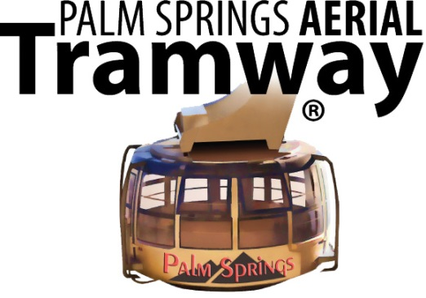

Dear Tour Operator/Media,

By issuing these digital images, the Palm Springs Aerial Tramway grants permission for the materials to be used solely for promotional purposes in conjunction with the Tramway. Use of these materials for commercial advertising is prohibited. Permission is given for a one-time use only.

Although not required, photo credit can read “Photo provided by the Palm Springs Aerial Tramway.”

If you have any questions, please do not hesitate to call me at 760.969.4385 or e-mail at mmorgan@pstramway.com.

Thank you!

Sincerely,

Madison Morgan
Public Relations & Special Events Manager

1 Tram Way, Palm Springs, CA 92262
Phone: 760.969.4385

